Continuous download: downloading the source code form github to dev server. Need git software

Continuos build: convert the src code into artifact need to install maven in dev server

Connect to dev server

Start the jenkins java -jar -jenkins.war

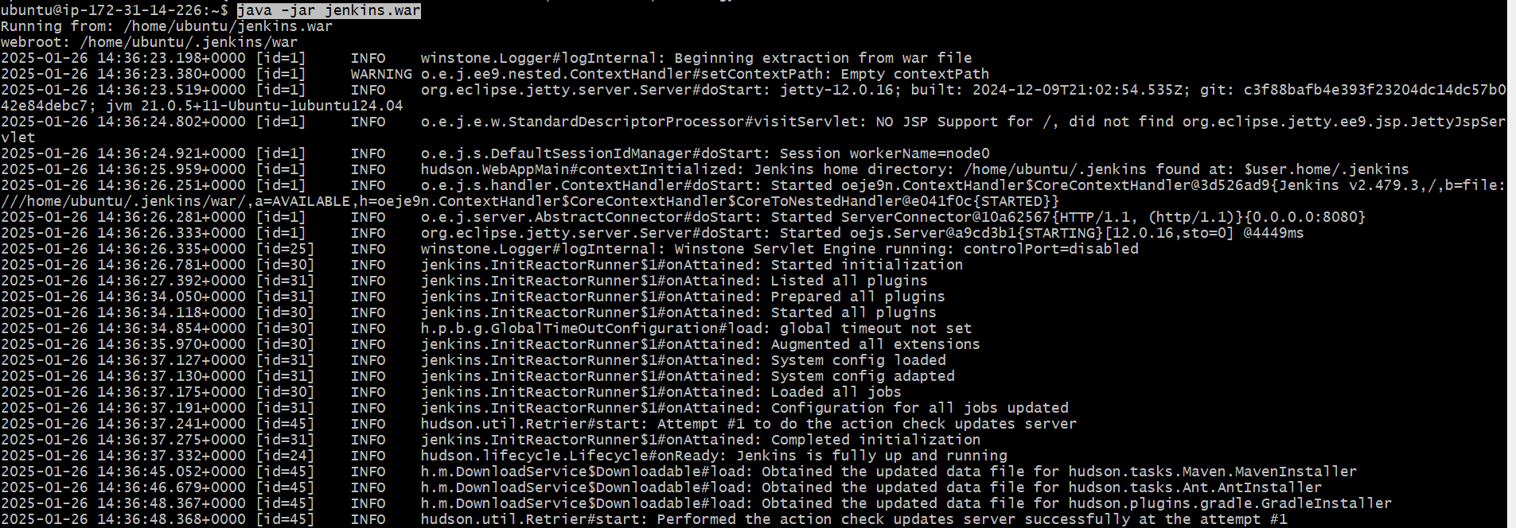

Open browser,take the public ip of devser and add port no 8080

Ex: <http://3.110.174.130:8080/>

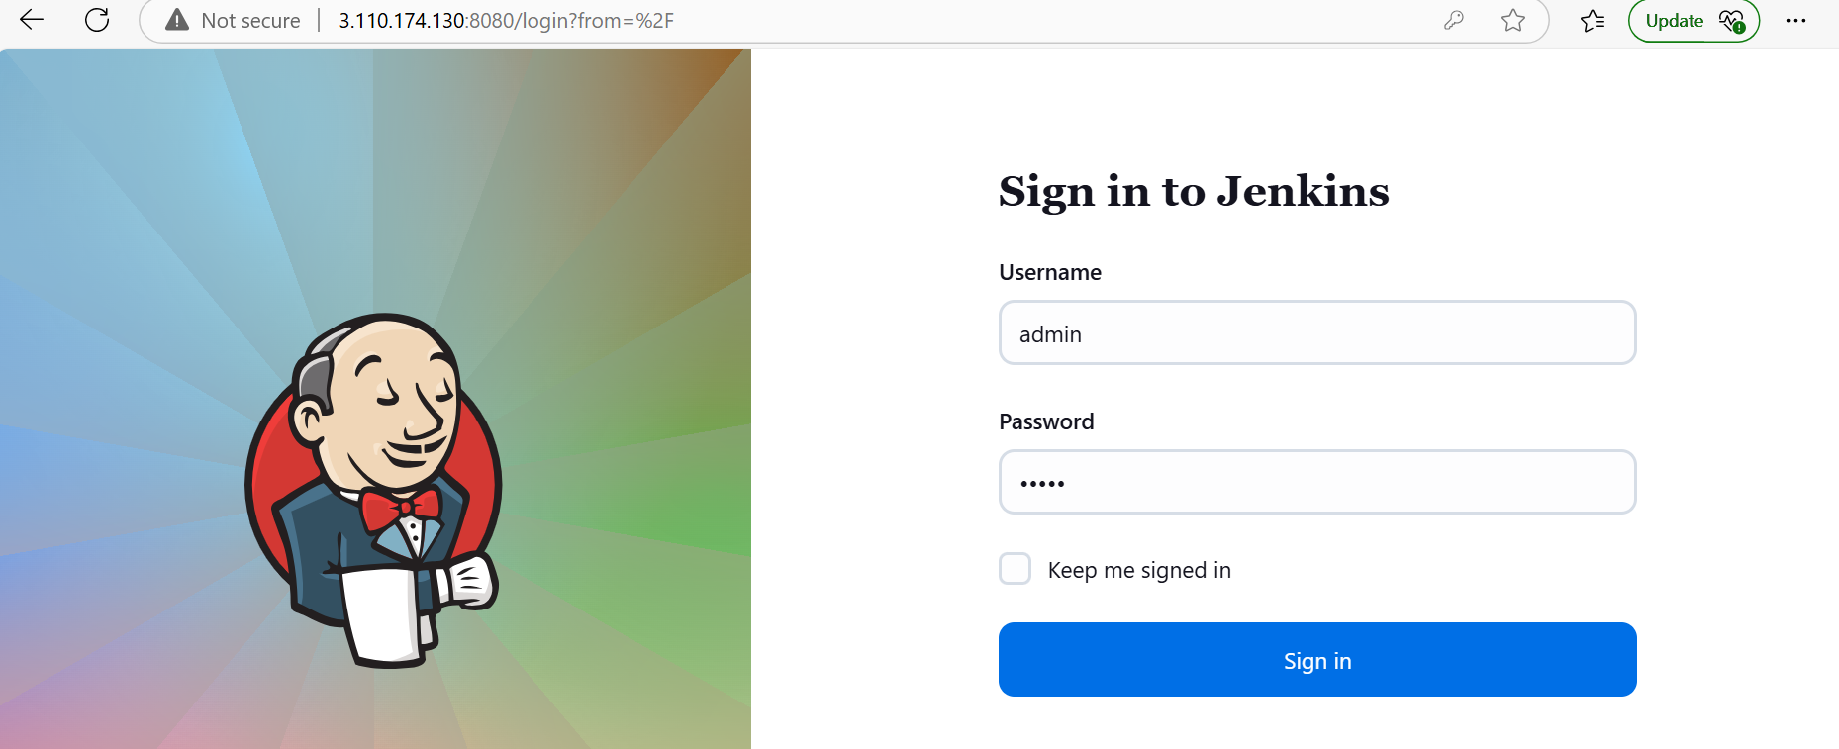

You need to create job to download the src code and create the artificat

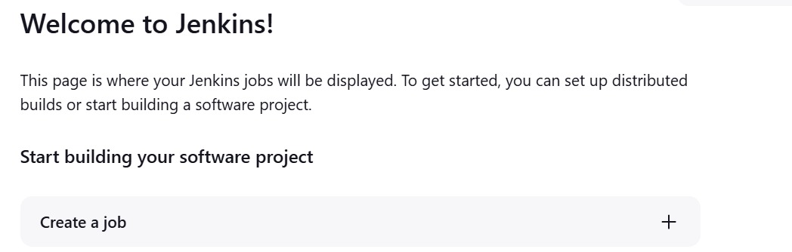

Give the job name

Select free style project

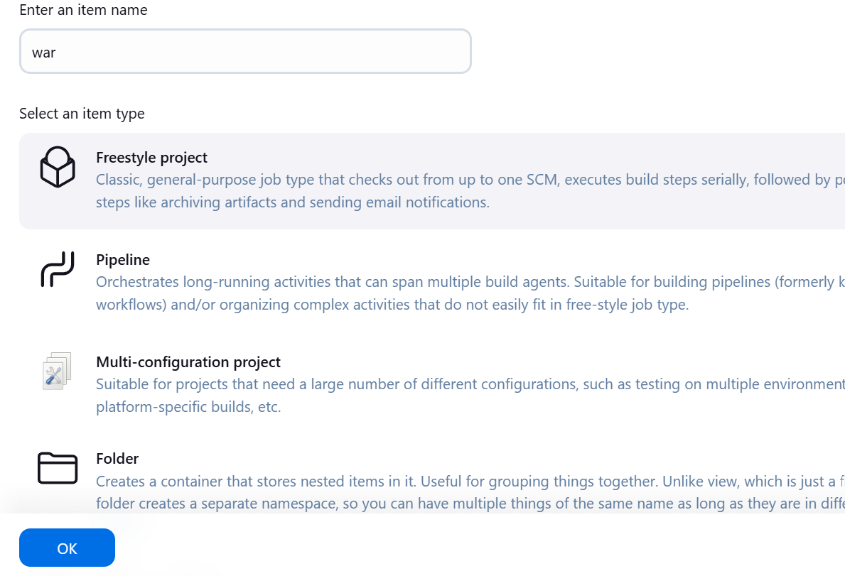

Select the git and copy paste the github repository url in the path click on apply and save

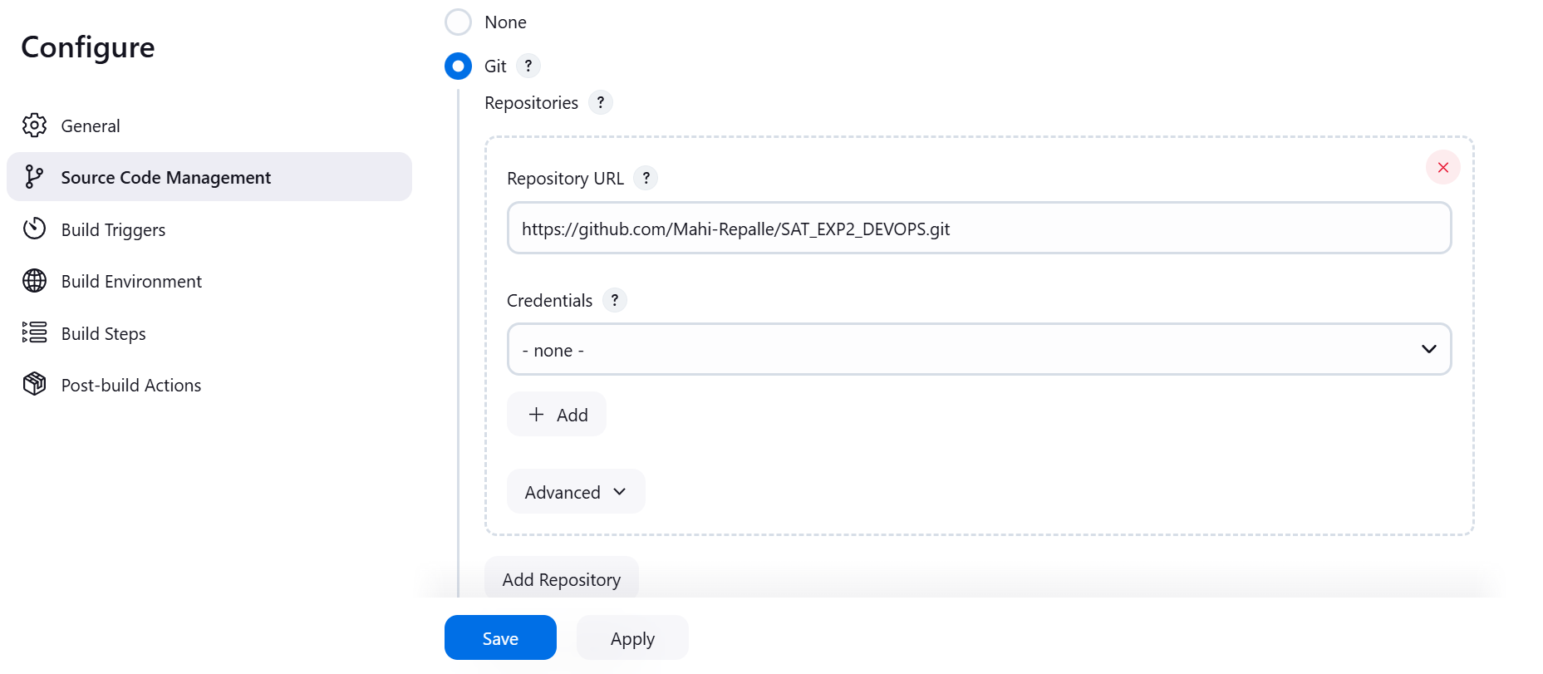

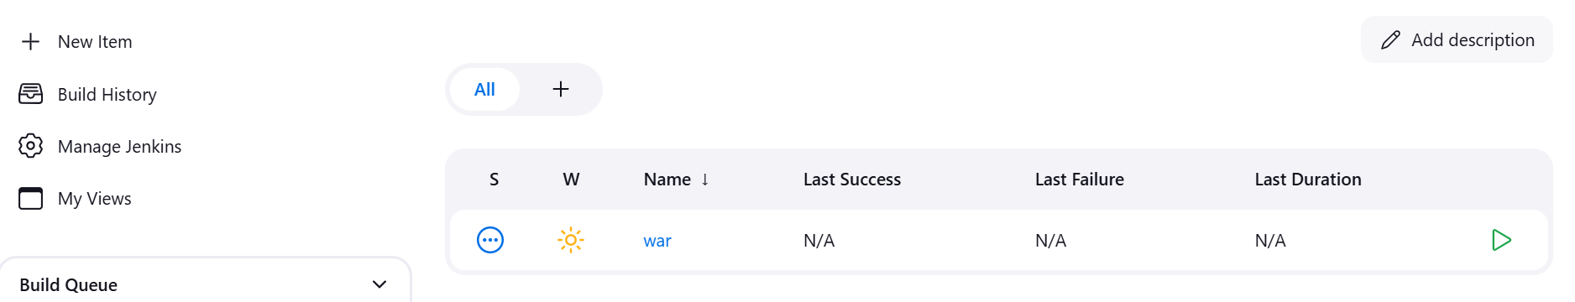

Now run the job

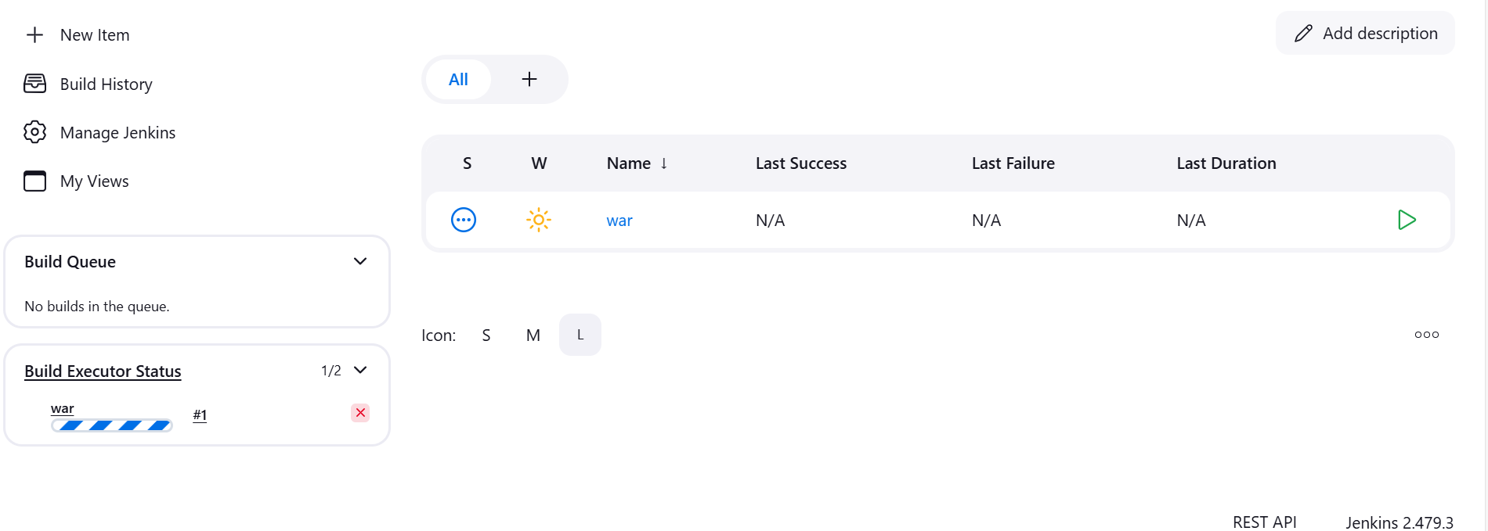

Now refresh

U can see the last success 1

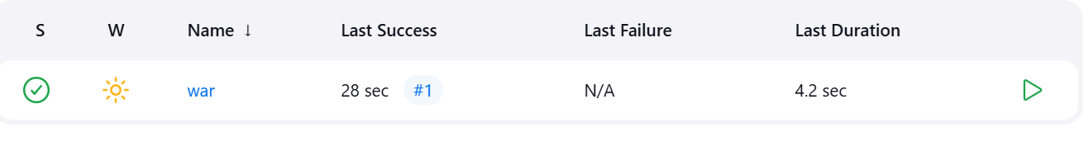

Click on console output

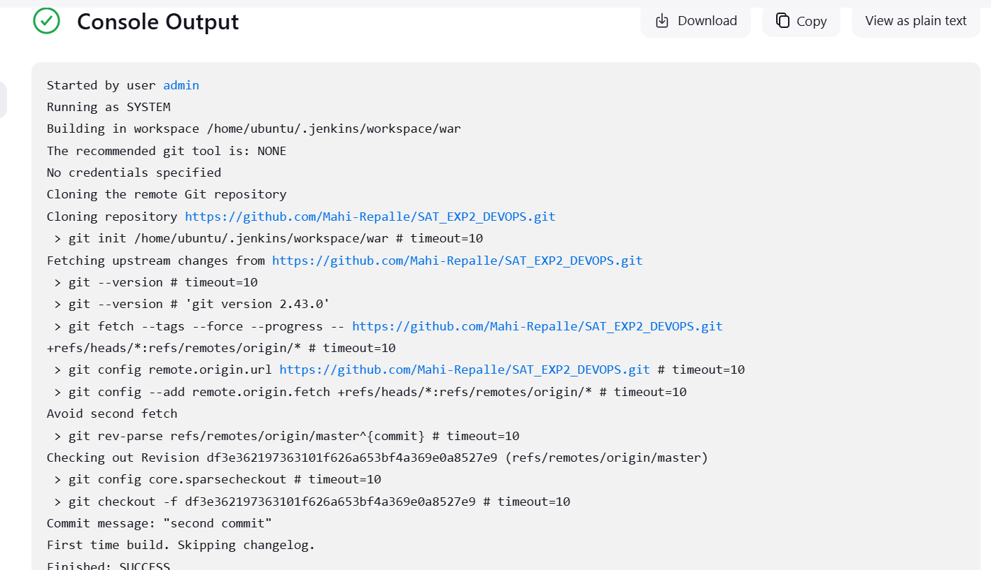

now the source code is downloaded into dev server

To check

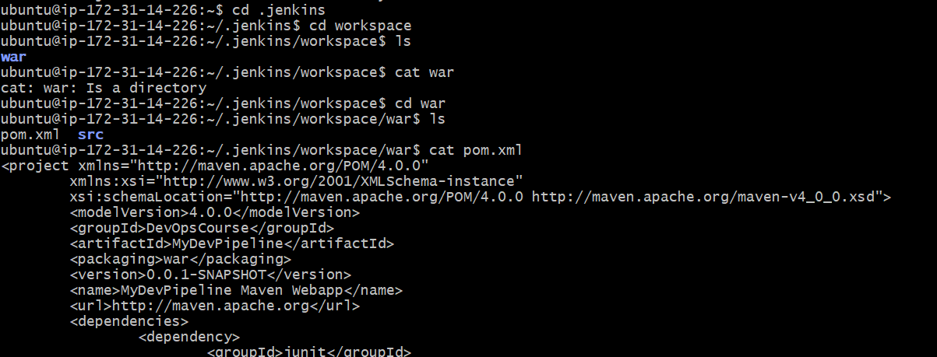

continuous download is completed

Now we will do the continuos build

Select the configure tab

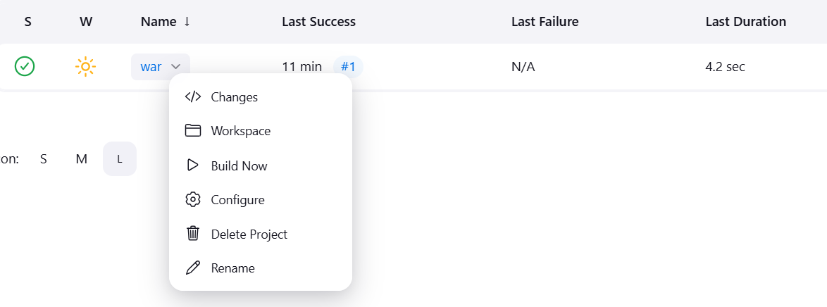

Select build environment-->select add build step-->select invoke top-level maven targets

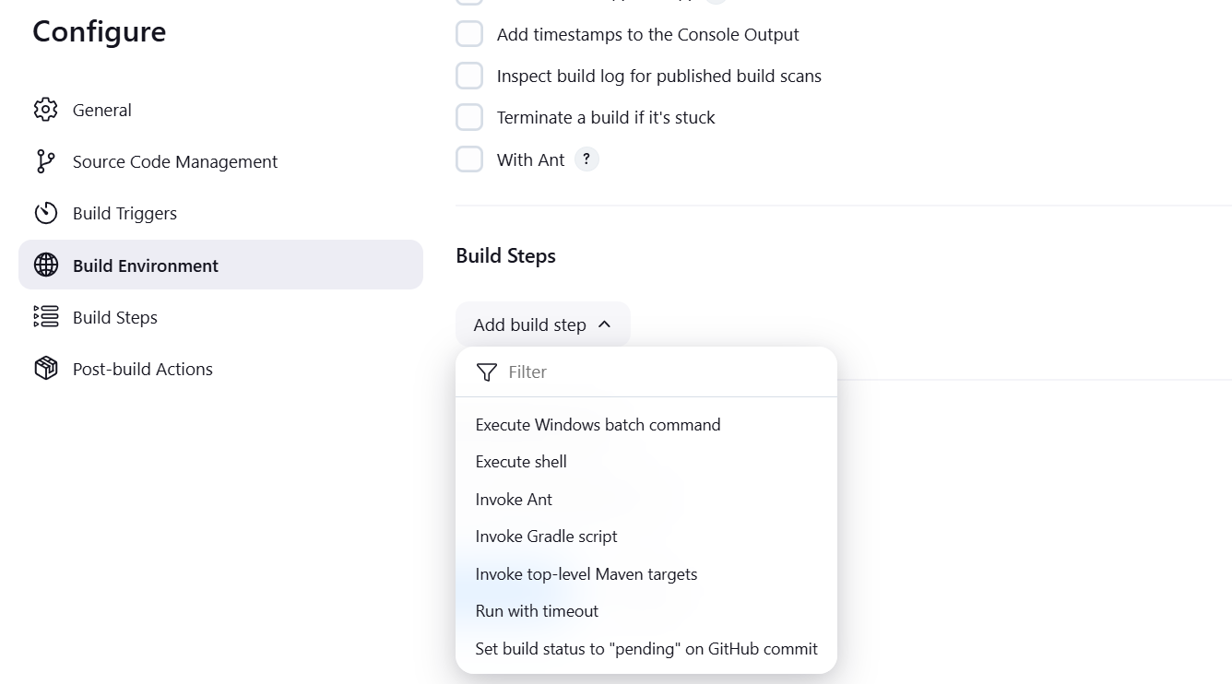

Goals: write the package apply and save

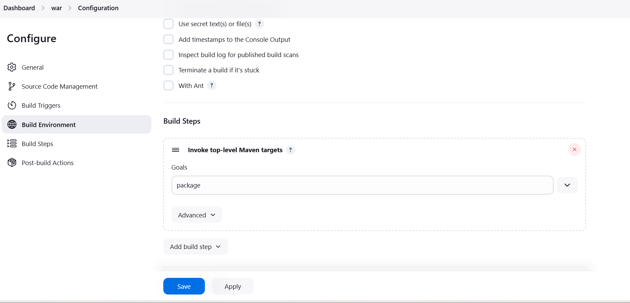

Go to the job run

